Lab # 12

System Programming



Teacher | Bibi Areej Khan
Student Name | Muhammad Ahmad Khan
Registration No | 23JZBCS0238

Department of CS&IT
University of Engineering and Technology Peshawar
(Jalozai Campus)

Objectives
- To understand the concept of Inter-Process Communication (IPC) in UNIX/Linux.
- To implement communication between processes using Pipes.
- To understand the creation and usage of FIFO (Named Pipes).
- To learn data sharing and synchronization among processes.
- To develop programs that enable communication between related and unrelated processes.

Theory
Inter-Process Communication (IPC) is a mechanism that allows different processes to exchange information and coordinate their actions. Since each process has its own memory space, special communication methods are required for sharing data.
Two commonly used IPC mechanisms are:

1. Pipe
A pipe is a unidirectional communication channel used mainly between related processes such as parent and child processes.
- Created using the pipe() system call.
- Data is transferred in FIFO (First In First Out) order.
- One end is used for reading and the other for writing.
- Pipe descriptors:
  - fildes[0] → Read End
  - fildes[1] → Write End

2. FIFO (Named Pipe)
FIFO stands for First In First Out and is also called a Named Pipe.
- Created using the mkfifo() system call.
- Exists as a file in the file system.
- Can be used by unrelated processes.
- Supports communication between separate programs.
IPC mechanisms improve process coordination and allow efficient data exchange in operating systems.

Task 1: Pipe Communication (Parent–Child)

Objective
Create a program where a child process sends a message through a pipe and the parent process reads and displays it.

Code
#include <stdio.h>
#include <unistd.h>
#include <string.h>

int main() {
int fildes[2];
pipe(fildes);

pid_t pid = fork();

if(pid == 0) {
// Child Process
close(fildes[0]);

char msg[] = "Hello from Child";
write(fildes[1], msg, strlen(msg) + 1);

close(fildes[1]);
}
else {
// Parent Process
close(fildes[1]);

char buffer[100];
read(fildes[0], buffer, sizeof(buffer));

printf("Parent received: %s\n", buffer);

close(fildes[0]);
}

return 0;
}

Compilation Command
gcc task1.c -o task1
./task1

Output

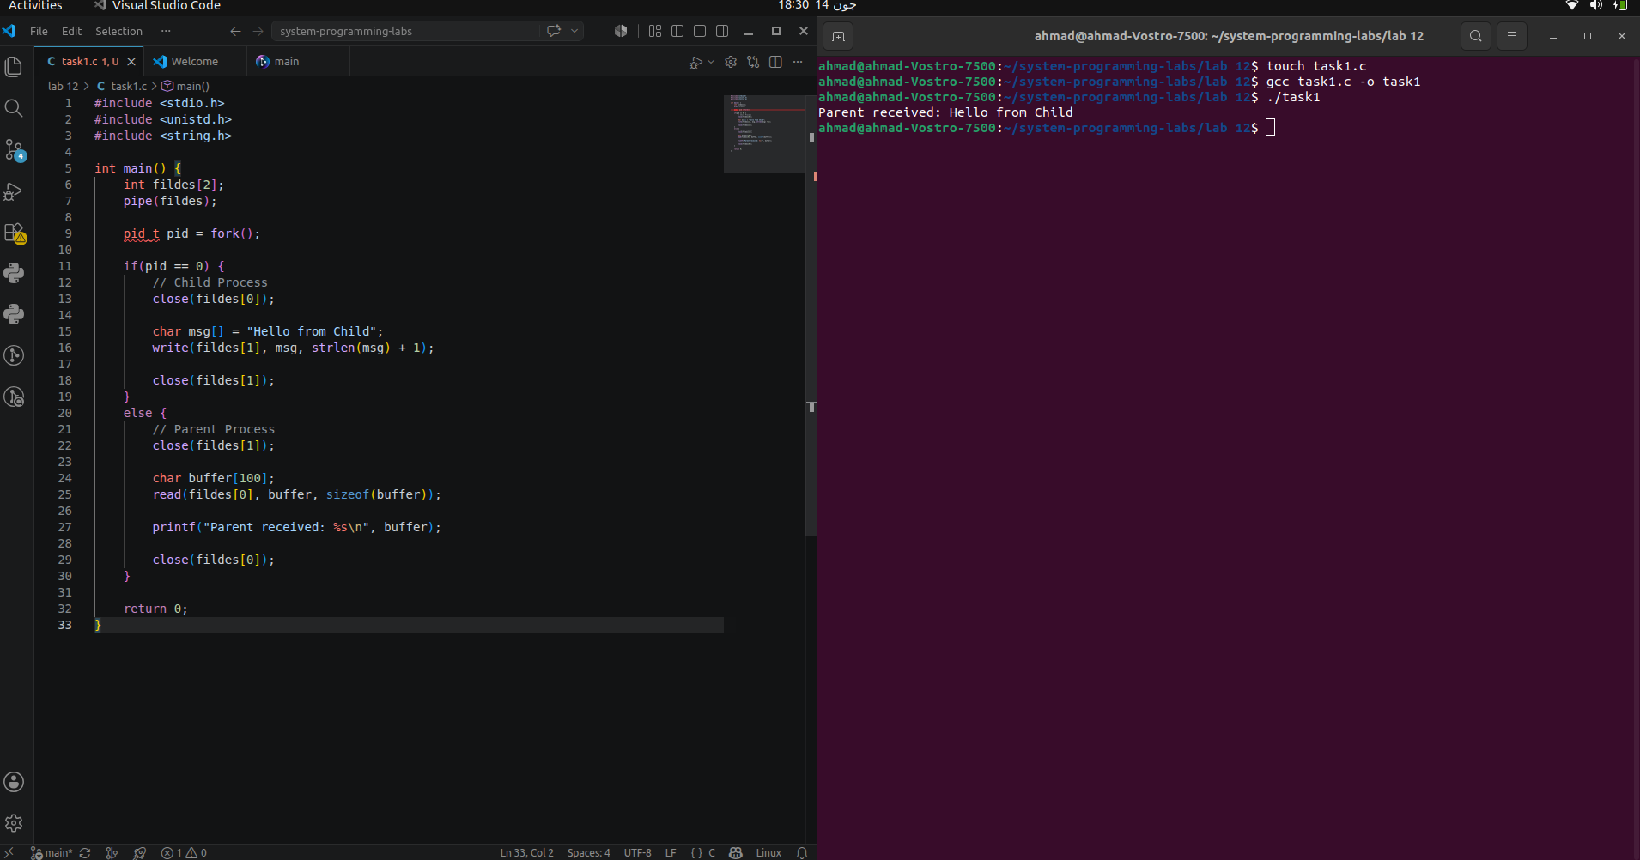
Task 2: Process Fan Using Pipe

Objective
Create multiple child processes that receive and display a message sent by the parent process.

Code
#include <stdio.h>
#include <unistd.h>
#include <string.h>

int main() {
int fildes[2];
pipe(fildes);
char msg[] = "Message from Parent";
for(int i = 0; i < 3; i++) {
if(fork() == 0) {

close(fildes[1]);

char buffer[100];
read(fildes[0], buffer, sizeof(buffer));

printf("Child %d received: %s\n", i + 1, buffer);

close(fildes[0]);
return 0;
}
}
close(fildes[0]);
write(fildes[1], msg, strlen(msg) + 1);
close(fildes[1]);
return 0;
}

Compilation Command
gcc task2.c -o task2
./task2

Output
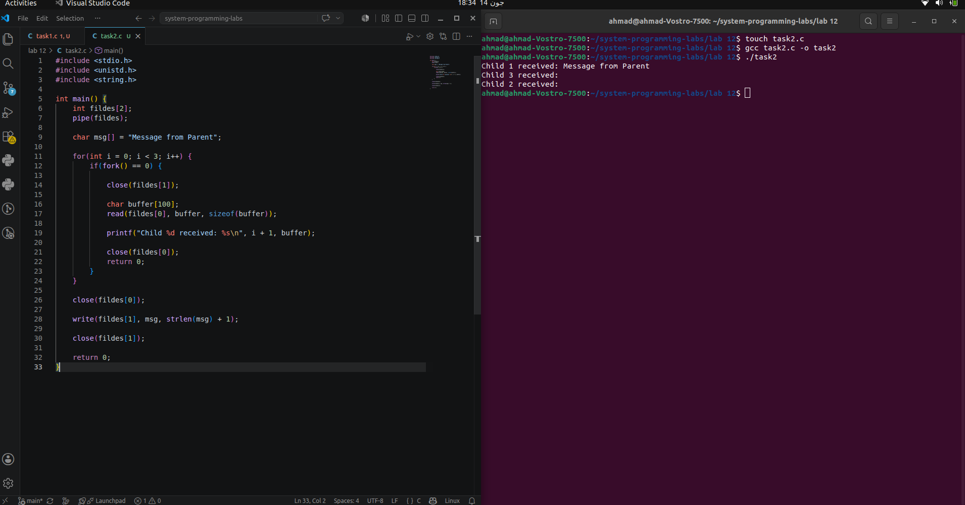

Task 3: FIFO Communication (Two Processes)

Objective
Create communication between two independent processes using a FIFO.

Writer Program

Code
#include <stdio.h>
#include <fcntl.h>
#include <sys/stat.h>
#include <unistd.h>

int main() {
char *fifo = "myfifo";
mkfifo(fifo, 0666);
char msg[100];
int fd = open(fifo, O_WRONLY);

printf("Enter Message: ");
fgets(msg, sizeof(msg), stdin);

write(fd, msg, sizeof(msg));

close(fd);
return 0;
}

Compilation Command
gcc writer.c -o writer

Reader Program

Code
#include <stdio.h>
#include <fcntl.h>
#include <sys/stat.h>
#include <unistd.h>

int main() {

char *fifo = "myfifo";

mkfifo(fifo, 0666);

char buffer[100];

int fd = open(fifo, O_RDONLY);

read(fd, buffer, sizeof(buffer));

printf("Received Message: %s", buffer);

close(fd);

return 0;
}

Compilation Command
gcc reader.c -o reader

Execution Command
Open two terminals.

Terminal 1
./reader

Terminal 2
./writer

Output

Writer

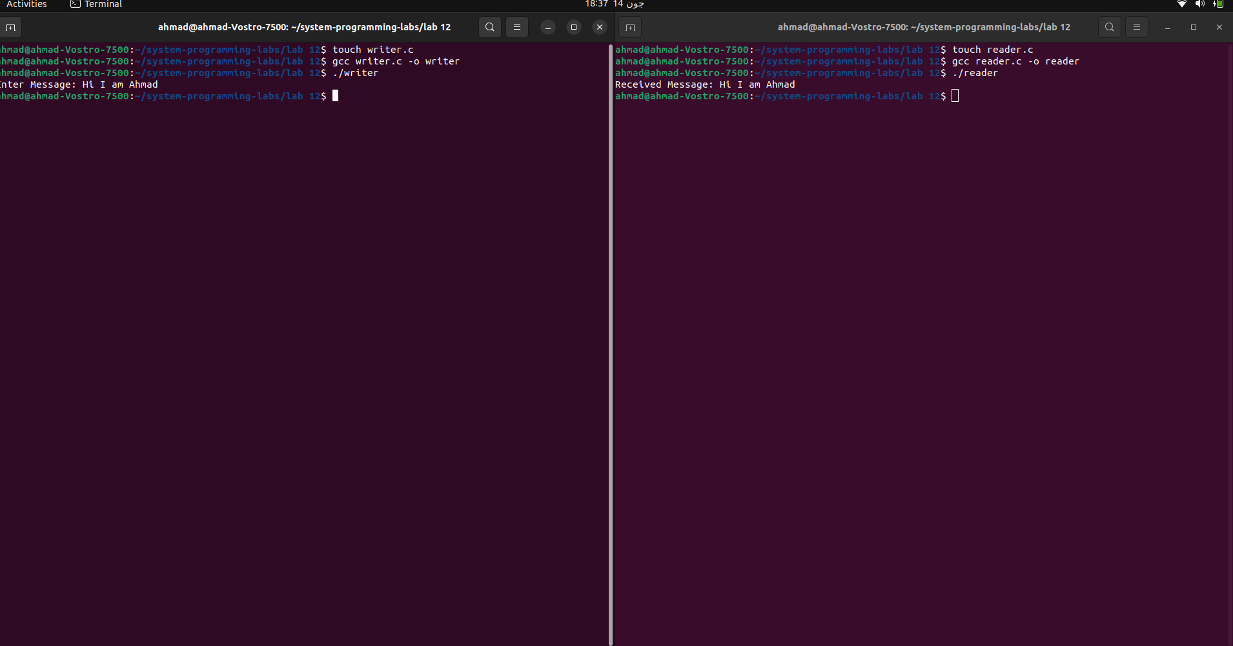
Task 4: Simple Chat Using FIFO

Objective
Create a simple two-way chat application using two FIFOs where both processes can send and receive messages.

Process 1

Code
#include <stdio.h>
#include <fcntl.h>
#include <sys/stat.h>
#include <unistd.h>
#include <string.h>

int main() {

char *fifo1 = "fifo1";
char *fifo2 = "fifo2";

mkfifo(fifo1, 0666);
mkfifo(fifo2, 0666);

char msg[100], buffer[100];
while(1) {
int fdw = open(fifo1, O_WRONLY);
printf("You: ");
fgets(msg, sizeof(msg), stdin);
write(fdw, msg, strlen(msg)+1);
close(fdw);
int fdr = open(fifo2, O_RDONLY);
read(fdr, buffer, sizeof(buffer));
printf("Friend: %s", buffer);
close(fdr);
}
return 0;
}

Process 2

Code
#include <stdio.h>
#include <fcntl.h>
#include <sys/stat.h>
#include <unistd.h>
#include <string.h>
int main() {

char *fifo1 = "fifo1";
char *fifo2 = "fifo2";

mkfifo(fifo1, 0666);
mkfifo(fifo2, 0666);

char msg[100], buffer[100];

while(1) {

int fdr = open(fifo1, O_RDONLY);

read(fdr, buffer, sizeof(buffer));

printf("Friend: %s", buffer);

close(fdr);

int fdw = open(fifo2, O_WRONLY);

printf("You: ");
fgets(msg, sizeof(msg), stdin);

write(fdw, msg, strlen(msg)+1);

close(fdw);
}
return 0;
}

Compilation Commands
gcc process1.c -o process1
gcc process2.c -o process2

Execution Commands

Terminal 1
./process1

Terminal 2
./process2

Output
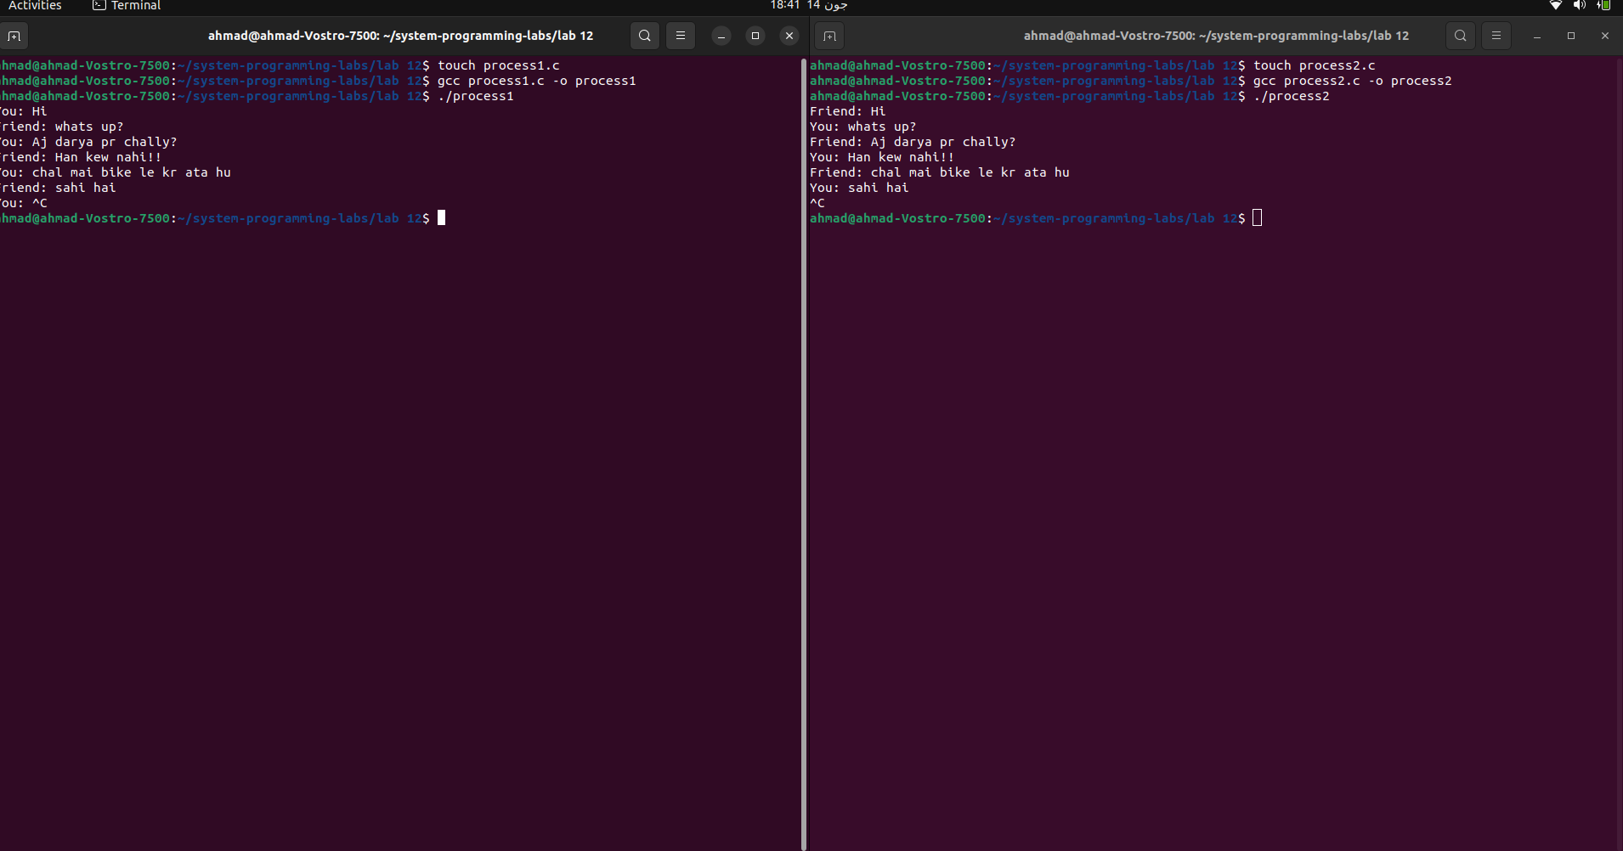

Conclusion
In this lab, we successfully studied Inter-Process Communication (IPC) mechanisms in Linux. Communication between parent and child processes was implemented using pipes, while communication between unrelated processes was achieved using FIFOs (Named Pipes). We also developed a simple chat application using two FIFOs for bidirectional communication. The lab enhanced our understanding of process synchronization, data sharing, and IPC techniques used in operating systems.

